Declaration of Original Work for SC2002/CE2002/CZ2002 Assignment
We hereby declare that the attached group assignment has been researched, undertaken, completed, and submitted as a collective effort by the group members listed below.
We have honored the principles of academic integrity and have upheld Student Code of Academic Conduct in the completion of this work.
We understand that if plagiarism is found in the assignment, then lower marks or no marks will be awarded for the assessed work. In addition, disciplinary actions may be taken.

Name | Course  (SC2002/CE2002 CZ2002) | Lab  Group | Signature /Date
Anmol Sharma | SC2002 | FCSJ | 19/Apr/2026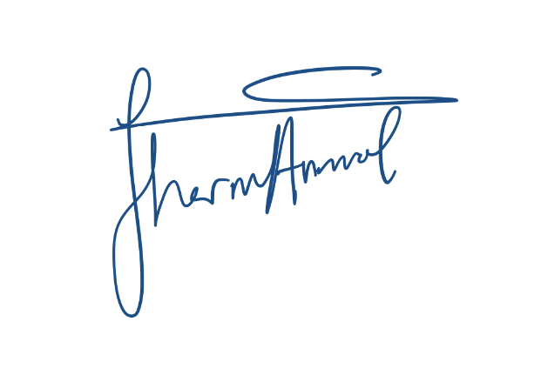
Fujita Natsuo | SC2002 | FCSJ | 19/Apr/2026
Kaung Sithu Hlaing | SC2002 | FCSJ | 19/Apr/2026
Luo Yuxuan | SC2002 | FCSJ | 19/Apr/2026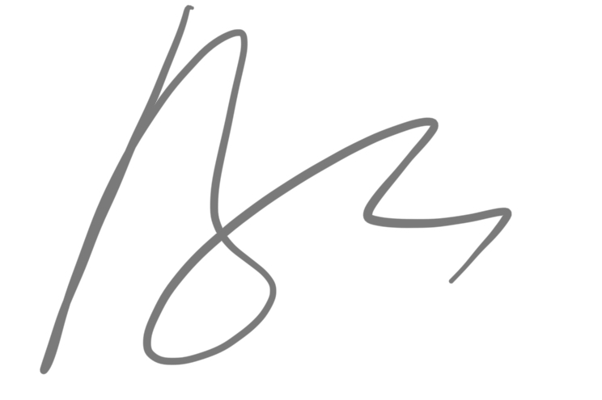
Tiya Bansal | SC2002 | FCSJ | 19/Apr/2026

Important notes:

- Name must EXACTLY MATCH the one printed on your Matriculation Card.
- Student Code of Academic Conduct includes the latest guidelines on usage of Generative AI and any other guidelines as released by NTU.

Declaration on Use of GAI (Generative Artificial Intelligence) Assistance in relation to Assignment/Project (to be submitted individually even for group projects)
I Luo Yuxuan (student name), luoy0051 @e.ntu.edu.sg (NTU email) honestly and sincerely make the following declaration in relation to the following course submission:
1. Name of course: OBJECT ORIENTED DESIGN & PROGRAMMING
2. Course Code: SC2002
3. Instructor: Shen Zhiqi / Li Fang
4. Title of Assignment/Project Submission: SC2002 Group Assignment

In relation to the foregoing I hereby declare that, fully and properly in accordance with the Assignment/Project Instructions I have (check where appropriate):
i. Used GAI as permitted to assist in generating key ideas only. ☑
ii. Used GAI as permitted to assist in generating a first text only. ☐

And/or
iii. Used GAI to refine syntax and grammar for correct language submission only. ☑
Or
iv. As it is not permitted: Not used GAI assistance in any way in the development or generation of this assignment or project. ☐
I also declare that I have :
a. Fully and honestly submitted the digital paper trail required under the assignment/project instructions; and that
b. Wherever GAI assistance has been employed in the submission in word or paraphrase or inclusion of a significant idea or fact suggested by the GAI assistant, I have acknowledged this by a footnote; and that,

c. Apart from the foregoing notices, the submission is wholly my own work.

Student Name & Signature Date _Luo Yuxuan___19/Apr/2026____________________
Declaration on Use of GAI (Generative Artificial Intelligence) Assistance in relation to Assignment/Project (to be submitted individually even for group projects)
I ____Kaung Sithu Hlaing________________________________________________ (student name), ________kaungsit001__________@e.ntu.edu.sg (NTU email) honestly and sincerely make the following declaration in relation to the following course submission:
1. Name of course: OBJECT ORIENTED DESIGN & PROGRAMMING
2. Course Code: SC2002
3. Instructor: Shen Zhiqi / Li Fang
4. Title of Assignment/Project Submission: SC2002 Group Assignment

In relation to the foregoing I hereby declare that, fully and properly in accordance with the Assignment/Project Instructions I have (check where appropriate):
i. Used GAI as permitted to assist in generating key ideas only. ☐
ii. Used GAI as permitted to assist in generating a first text only. ☐

And/or
iii. Used GAI to refine syntax and grammar for correct language submission only. ☐
Or
iv. As it is not permitted: Not used GAI assistance in any way in the development or generation of this assignment or project. ☑
I also declare that I have :
a. Fully and honestly submitted the digital paper trail required under the assignment/project instructions; and that
b. Wherever GAI assistance has been employed in the submission in word or paraphrase or inclusion of a significant idea or fact suggested by the GAI assistant, I have acknowledged this by a footnote; and that,
c. Apart from the foregoing notices, the submission is wholly my own work.

Student Name & Signature Date __Kaung Sithu Hlaing, 19/04/2026, _____________________

Declaration on Use of GAI (Generative Artificial Intelligence) Assistance in relation to Assignment/Project (to be submitted individually even for group projects)
I Fujita Natsuo (student name), natsuo001@e.ntu.edu.sg (NTU email) honestly and sincerely make the following declaration in relation to the following course submission:
1. Name of course: OBJECT ORIENTED DESIGN & PROGRAMMING
2. Course Code: SC2002
3. Instructor: Shen Zhiqi / Li Fang
4. Title of Assignment/Project Submission: SC2002 Group Assignment

In relation to the foregoing I hereby declare that, fully and properly in accordance with the Assignment/Project Instructions I have (check where appropriate):
i. Used GAI as permitted to assist in generating key ideas only. ☐
ii. Used GAI as permitted to assist in generating a first text only.☐

And/or
iii. Used GAI to refine syntax and grammar for correct language submission only.☐
Or
iv. As it is not permitted: Not used GAI assistance in any way in the development or generation of this assignment or project.☑
I also declare that I have :
a. Fully and honestly submitted the digital paper trail required under the assignment/project instructions; and that
b. Wherever GAI assistance has been employed in the submission in word or paraphrase or inclusion of a significant idea or fact suggested by the GAI assistant, I have acknowledged this by a footnote; and that,
c. Apart from the foregoing notices, the submission is wholly my own work.

Student Name & Signature Date:Fujita Natsuo 4/19/26

I ___________________________Anmol Sharma_______________________________ (student name), _______anmol010___________@e.ntu.edu.sg (NTU email) honestly and sincerely make the following declaration in relation to the following course submission:
1. Name of course: OBJECT ORIENTED DESIGN & PROGRAMMING
2. Course Code: SC2002
3. Instructor: Shen Zhiqi / Li Fang
4. Title of Assignment/Project Submission: SC2002 Group Assignment

In relation to the foregoing I hereby declare that, fully and properly in accordance with the Assignment/Project Instructions I have (check where appropriate):
i. Used GAI as permitted to assist in generating key ideas only. ☐
ii. Used GAI as permitted to assist in generating a first text only. ☐

And/or
iii. Used GAI to refine syntax and grammar for correct language submission only. ☐
Or
iv. As it is not permitted: Not used GAI assistance in any way in the development or generation of this assignment or project. ☐
I also declare that I have :
a. Fully and honestly submitted the digital paper trail required under the assignment/project instructions; and that
b. Wherever GAI assistance has been employed in the submission in word or paraphrase or inclusion of a significant idea or fact suggested by the GAI assistant, I have acknowledged this by a footnote; and that,
c. Apart from the foregoing notices, the submission is wholly my own work.

Student Name & Signature Date _____________Anmol Sharma, 19 April 2026________________

Declaration on Use of GAI (Generative Artificial Intelligence) Assistance in relation to Assignment/Project (to be submitted individually even for group projects)
I ____Tiya Bansal___________________________________________ (student name), _____tiya0001______@e.ntu.edu.sg (NTU email) honestly and sincerely make the following declaration in relation to the following course submission:
1. Name of course: OBJECT ORIENTED DESIGN & PROGRAMMING
2. Course Code: SC2002
3. Instructor: Shen Zhiqi / Li Fang
4. Title of Assignment/Project Submission: SC2002 Group Assignment

In relation to the foregoing I hereby declare that, fully and properly in accordance with the Assignment/Project Instructions I have (check where appropriate):
i. Used GAI as permitted to assist in generating key ideas only. ☐
ii. Used GAI as permitted to assist in generating a first text only. ☐

And/or
iii. Used GAI to refine syntax and grammar for correct language submission only. ☐
Or
iv. As it is not permitted: Not used GAI assistance in any way in the development or generation of this assignment or project. ☐
I also declare that I have :
a. Fully and honestly submitted the digital paper trail required under the assignment/project instructions; and that
b. Wherever GAI assistance has been employed in the submission in word or paraphrase or inclusion of a significant idea or fact suggested by the GAI assistant, I have acknowledged this by a footnote; and that,
c. Apart from the foregoing notices, the submission is wholly my own work.

Student Name & Signature Date ____________Tiya Bansal, 19 Apr 2026________________

